Lab 2

1. Write a program to generate a network in accordance to the following to the sequence of steps.

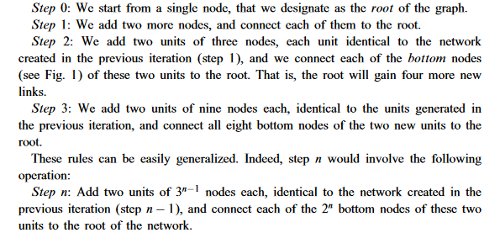

The generation of this whole structure can be represented pictorially as follows.

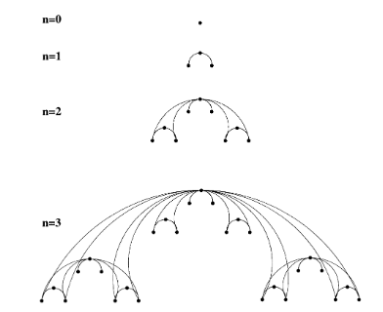

In the above figure, n represents the step. You must generate the network as large as possible (It depends on the capacity of your PC’s RAM) or at least the 10-th step.

After the generation of this network, plot its degree distribution such that the

x-axis is having the degree k while the y-axis is having probability of a node having degree k.

and write your observation.

Save the adjacency matrix of this graph or edge list and then visualize this graph in to the (any) tool that you have investigated into the first lab.

If you are saving as an edge list, then you have to generate the edge list in accordance to the following example of a triangle.

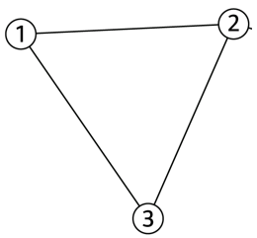

The edge list of this triangle would be a two dimensional matrix in which first entry is a source node while the second entry is a destination node like

1. 2
2. 3
3. 3